DEEP LEARNING PROJECT REVIEW

FloodWatch
AI-Powered Flood Detection and Response Planning
Using Sentinel-1 SAR imagery, deep learning (U-Net + ResNet34) and population-aware risk analysis

Team Member | Roll Number | Role
Akhilon S | 24BAD008 | Team member
Gowtham S | 24BAD028 | Team member

Abstract
Floods are one of the most common and damaging natural disasters in India. When one happens, rescue teams need quick answers: where is the water, how much area is covered, which communities need help first, and where can people go to stay safe. Reading satellite images by hand takes hours or even days, and most existing tools only give a flood map without saying who is affected.
FloodWatch is our web-based system for tackling this problem. The user uploads a Sentinel-1 SAR image with two bands (VV and VH). We normalise it and feed it to a PyTorch U-Net model with a ResNet34 encoder, which decides for every pixel whether it is flooded or not. From that mask we work out the flooded area in km² and the flood percentage, draw it on an interactive Leaflet map, and use WorldPop population data to give a High, Medium or Low risk rating. The system also lists the zones that need attention first and suggests nearby safe areas and hospitals.
We trained the model on the Sen1Floods11 dataset (252 training and 89 validation images) using Binary Cross-Entropy and Dice loss together, with the Adam optimiser. On the validation images it scored 93.37% pixel accuracy, 62.12% precision, 79.08% recall, 69.58% Dice/F1 and 53.35% IoU. This report explains the problem, our system design, the deep-learning model in detail, the results we got, and what we plan to do next.
Keywords: flood detection, Sentinel-1 SAR, semantic segmentation, U-Net, ResNet34, PyTorch, Sen1Floods11, WorldPop, risk analysis

Contents
No. | Section | Page
1 | Abstract | 2
2 | Introduction and Problem Statement | 3
3 | Climate Connection, Objectives and Novelty | 4
4 | System Architecture and Workflow | 5
5 | Deep Learning Model I: Dataset and SAR Preprocessing | 6
6 | Deep Learning Model II: Model Architecture | 7
7 | Deep Learning Model III: Training Methodology | 8
8 | Deep Learning Model IV: Evaluation and Results | 9
9 | Deep Learning Model V: Inference, Analysis and Limitations | 10
10 | Population-Aware Risk Analysis and Web Application | 11
11 | Feasibility, Scalability and Impact | 12
12 | Conclusion and References | 13

1. Introduction and Problem Statement

1.1 Problem understanding
During a flood, rescue teams have limited boats, staff and supplies, so they have to decide very quickly where to send them. They mainly need to know four things: where the flooding is, how big the flooded area is, which places and communities need help immediately, and where people can be moved safely. Checking satellite images by hand and doing ground surveys both take too long when decisions are needed within a few hours.

1.2 Target users and impact
Question | Answer
Who is affected? | Disaster management authorities, NGOs and local government bodies coordinating response, and above all communities in flood-prone regions such as Assam, Bihar, Kerala, Odisha, West Bengal and Tamil Nadu.
How are they affected? | They rely on slow manual surveys and generic satellite maps that show flood extent but not which areas hold the most people at risk, delaying rescue prioritisation when every hour matters.
What if it is not solved? | Rescue resources keep going to the largest flooded area rather than the most populated one, increasing preventable casualties and slowing recovery for the communities that need help most.

1.3 Problem validation and evidence
- India faces recurring, high-casualty flood events: Kerala (2018), Chennai (2023) and annual flooding across Assam and Bihar.
- Manual and ground-survey flood assessment typically takes hours to days, delaying rescue prioritisation.
- Published research on Sentinel-1 plus deep-learning flood segmentation (the Sen1Floods11 benchmark) reports strong results, including studies validated on the Kerala 2018 and Bihar flood events.
- Existing tools largely stop at producing a flood map. They do not rank affected zones by population impact, which is the specific gap this project addresses.

1.3.1 Why SAR imagery?
Floods usually come with heavy clouds, and clouds block ordinary (optical) satellite cameras. Synthetic Aperture Radar (SAR), such as Sentinel-1, sends out its own microwave signal, so it works at night and can see through clouds. Calm water bounces the signal away from the satellite, so flooded areas show up dark in both the VV and VH bands. That is the reason we chose Sentinel-1 data for FloodWatch.

2. Climate Connection, Objectives and Novelty

2.1 Connection to climate
Floods are getting worse because climate change is bringing heavier and more unpredictable monsoon rain and more extreme storms. The people most at risk are those living in crowded, low-lying areas, along with hospitals, roads, schools and farming communities that depend on the land. FloodWatch supports climate adaptation and resilience, because it helps response teams act faster and more accurately as floods become more frequent and severe.

2.2 Project objectives
- Detect flooded pixels from Sentinel-1 VV + VH imagery using a deep-learning segmentation model.
- Estimate the flooded area in km² and the flood percentage of the scene.
- Estimate the population exposed to flooding using WorldPop data and classify risk as High, Medium or Low.
- Rank high-priority flood zones so rescue teams know where to respond first.
- Suggest nearby dry evacuation zones and hospitals.
- Deliver everything through a simple web dashboard with drag-and-drop GeoTIFF upload and an interactive map.

2.3 What makes FloodWatch novel?
Flood segmentation from SAR images and risk mapping based on exposed population have both been studied separately before. What is new in FloodWatch is that we put them together in one working pipeline:
- Most existing tools stop at a flood map. FloodWatch goes one step further and adds population exposure, so the output is a ranked priority list that teams can act on.
- It covers the last step that is usually missing: it turns the raw segmentation result into a clear list of where rescue teams should go first, along with nearby safe zones and hospitals.
- Everything is built on free, openly available data and open-source tools, so local authorities and NGOs can use it without a big budget.

Typical flood-map tool | FloodWatch
Shows flood extent only | Shows extent, area (km²) and flood percentage
Treats all flooded land equally | Weights risk by people exposed and population density
Leaves prioritisation to the analyst | Produces ranked priority tiles automatically
No guidance on where to go | Suggests safe evacuation zones and nearby hospitals

3. System Architecture and Workflow
FloodWatch is a complete web application with three parts. The deep-learning back end detects the flooded pixels, a geospatial and risk layer turns the mask into useful numbers, and a Flask and Leaflet front end shows the results to the user. The three main entry points of the codebase are train.py (model training), infer.py (inference) and app.py (the Flask web application).
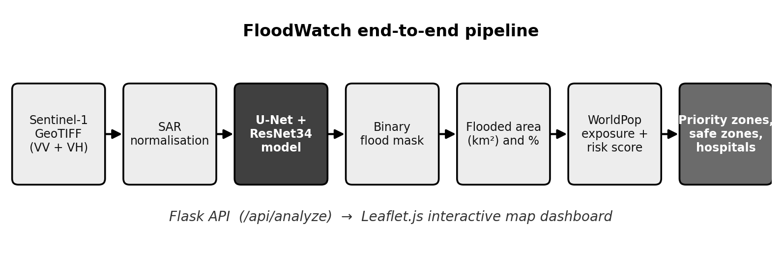
Figure 1. End-to-end FloodWatch pipeline from SAR GeoTIFF to ranked response recommendations.

3.1 Workflow
- Upload: the user uploads a two-band Sentinel-1 GeoTIFF (VV and VH) through the dashboard.
- Normalise: SAR values are clipped and scaled to the range 0 to 1.
- Predict: the trained U-Net outputs a per-pixel flood probability, which is converted to a binary flood mask.
- Measure: flooded area in km² and flood percentage are calculated using the raster’s georeferenced pixel size.
- Visualise: a PNG mask overlay is drawn on a Leaflet map over OpenStreetMap tiles.
- Assess risk: WorldPop data gives the exposed population; a risk score and High/Medium/Low class are produced.
- Prioritise: 32 × 32-pixel tiles are ranked, and nearby safe zones and hospitals are suggested.

3.2 Technology stack
Area | Technology
Deep learning | PyTorch, Segmentation Models PyTorch, U-Net with ResNet34 encoder
Data augmentation | Albumentations
Geospatial processing | Rasterio, NumPy, OpenCV (PNG mask overlays)
Backend | Flask (endpoints: /, /api/health, /api/analyze)
Frontend | HTML, CSS, JavaScript, Leaflet.js, OpenStreetMap tiles
Data sources | Sentinel-1 SAR (VV + VH), Sen1Floods11, WorldPop

4. Deep Learning Model I: Dataset and SAR Preprocessing

4.1 Problem formulation
We treat flood detection as a binary semantic segmentation problem. Image classification gives one label to a whole image, but segmentation gives a label to every single pixel. Here each pixel is either 0 = non-flooded or 1 = flooded. The network produces one probability map (classes = 1), and we apply a threshold to it to get the final binary mask.

4.2 The Sen1Floods11 dataset
We built the project around Sen1Floods11, a public dataset for flood mapping with Sentinel-1. It contains SAR images with VV and VH bands, along with ground-truth flood masks and some hand-labelled flood examples. Our code can read the data either from normal GeoTIFF folders or from the STAC catalogue that comes with the dataset.
Property | Value
Input data | Sentinel-1 SAR, two bands (VV and VH polarisation)
Labels | Hand-labelled ground-truth flood masks (0 = non-flooded, 1 = flooded)
Training images | 252
Validation images | 89
Task | Pixel-wise binary segmentation

4.3 SAR preprocessing
Sentinel-1 backscatter values are in decibels (dB) and run roughly from −50 dB to +1 dB. Giving such raw values directly to a neural network makes training unstable, so we clip each band to this range and apply min-max normalisation:
x_norm = (x − min_dB) / (max_dB − min_dB), min_dB ≈ −50, max_dB ≈ 1
After this step every input value lies between 0 and 1, which is easier for the network to learn from. Water reflects very little signal, so it ends up near the low end, while land and buildings look brighter.

4.4 Data augmentation
Since we have only 252 training images, the model could easily overfit. To avoid this, dataset.py uses Albumentations to apply random changes to the training images, which gives the model more variety to learn from and helps it work better on new images:
- Horizontal and vertical flips
- 90-degree rotations
- Random resized crops, followed by resizing to the network input size
Each transformation is applied in the same way to the SAR image and its mask, so the labels always stay matched to the pixels. We do not augment the validation images, so the metrics show the real performance.

5. Deep Learning Model II: Model Architecture

5.1 Overview
FloodWatch uses a U-Net created with the Segmentation Models PyTorch (SMP) library. SMP gives ready-made segmentation architectures and lets us swap in different pretrained encoders easily. We create the model like this:
smp.Unet(encoder_name="resnet34", in_channels=2, classes=1)
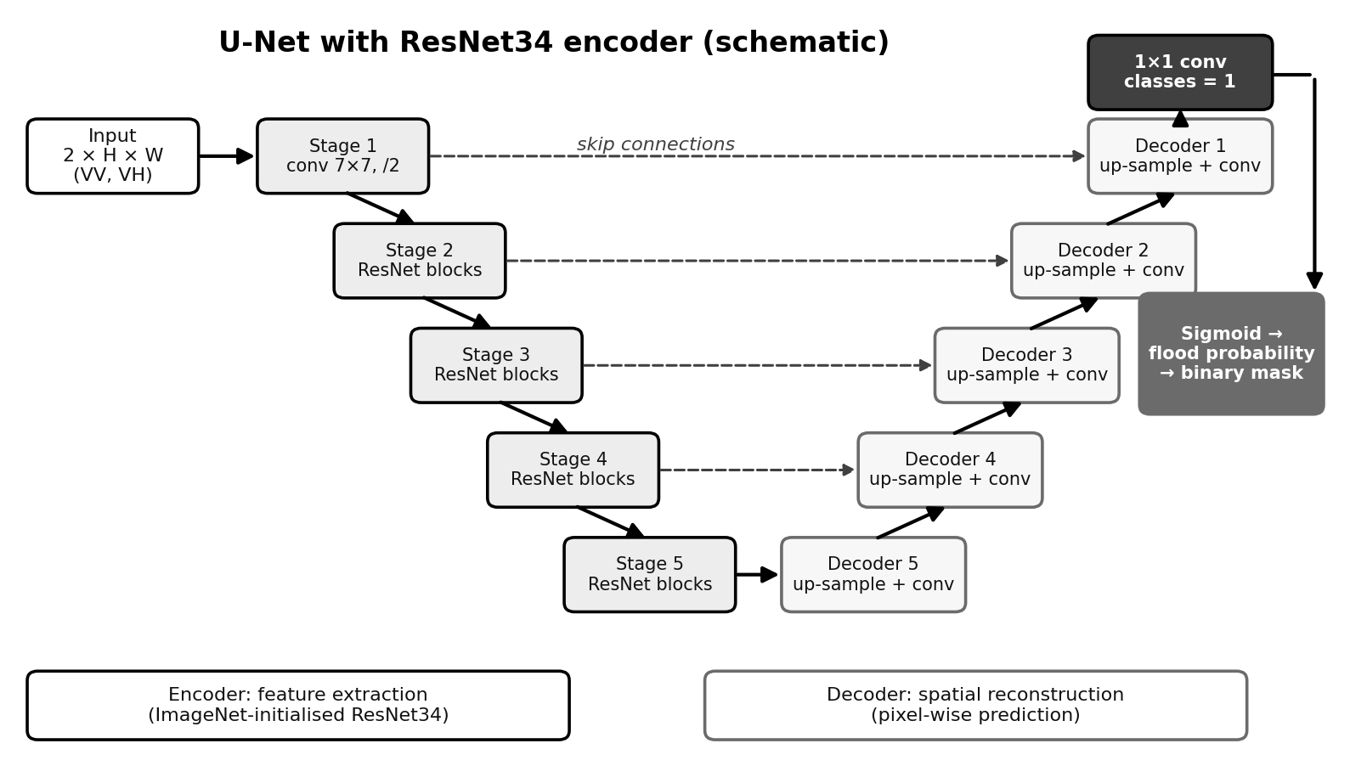
Figure 2. Schematic of the U-Net with ResNet34 encoder used in FloodWatch.

5.2 Encoder: ResNet34
The encoder is a ResNet34, a residual network with 34 layers. The shortcut (residual) connections inside its blocks help the gradients flow through the deep layers, so it can learn textures and patterns from the SAR images well. It gradually shrinks the image into smaller feature maps. Its first convolution takes two input channels (VV and VH) instead of the usual three RGB channels.

5.3 Decoder and skip connections
The decoder takes the deepest features from the encoder and enlarges them step by step until they reach the original image size. At each step it also receives the matching detailed feature map from the encoder through a skip connection. This way the model knows both what is in the image and where it is, which gives cleaner flood boundaries.

5.4 Output head
A final 1 × 1 convolution (classes = 1) gives one value per pixel. A sigmoid changes this value into a flood probability between 0 and 1, and the probability map is then turned into the binary flood mask that we use for the area and risk calculations.
Component | Choice in FloodWatch
Architecture | U-Net (encoder–decoder with skip connections)
Encoder | ResNet34
Input channels | 2 (VV, VH)
Output classes | 1 (flood probability map)
Framework | PyTorch with Segmentation Models PyTorch

6. Deep Learning Model III: Training Methodology

6.1 Training setup
Training is done in train.py with PyTorch, which takes care of tensor operations, GPU/CPU execution, backpropagation, optimisers and saving the model. The code picks the device by itself: it uses CUDA if a GPU is available, otherwise the CPU. The model starts with ImageNet-pretrained encoder weights, which gives it a good starting point even though our inputs are SAR images and not RGB photos. During inference, infer.py loads the full trained checkpoint.

6.2 Loss function
The training loss is the sum of two terms that complement each other:
Total loss = BCE loss + Dice loss
- BCEWithLogitsLoss measures the classification error for each pixel. It is also numerically stable because the sigmoid and cross-entropy are combined in a single operation.
- Dice loss directly tries to increase the overlap between the prediction and the ground truth. It works well with imbalanced classes, which is important here because flooded pixels are usually much fewer than background pixels.
Dice = 2 |P ∩ G| / (|P| + |G|) Dice loss = 1 − Dice

6.3 Optimiser and learning-rate schedule
We use the Adam optimiser, which adjusts the step size of each weight automatically during training. The learning rate is set to 1e-4:
torch.optim.Adam(model.parameters(), lr=1e-4)
A ReduceLROnPlateau scheduler keeps an eye on the validation IoU. When the IoU stops improving, the learning rate is lowered, which helps the model settle properly instead of bouncing around.

6.4 Training summary
Setting | Value
Framework | PyTorch
Loss | BCEWithLogitsLoss + Dice loss
Optimiser | Adam, learning rate 1e-4
Scheduler | ReduceLROnPlateau, monitored on validation IoU
Augmentation | Flips, 90° rotations, random resized crops (Albumentations)
Initialisation | ImageNet-pretrained ResNet34 encoder
Model-selection metric | Validation IoU
Data split | 252 training / 89 validation images

7. Deep Learning Model IV: Evaluation and Results

7.1 Evaluation metrics
We evaluate the model pixel by pixel using the usual segmentation metrics. Here TP, FP, TN and FN are the numbers of true positive, false positive, true negative and false negative pixels, with flood as the positive class:
Accuracy = (TP+TN) / (TP+TN+FP+FN) Precision = TP / (TP+FP)
Recall = TP / (TP+FN) IoU = |P ∩ G| / |P ∪ G| = TP / (TP+FP+FN)
IoU (Intersection over Union) is our main metric. It shows how much the predicted flood area overlaps with the labelled flood area, and it is also the value the learning-rate scheduler watches.

7.2 Validation results
Metric | Score | Interpretation
Pixel accuracy | 93.37% | Most pixels are classified correctly, but accuracy is inflated by the many non-flooded pixels.
Precision | 62.12% | Of pixels predicted as flood, about 62% are truly flooded.
Recall | 79.08% | The model finds about 79% of the truly flooded pixels.
Dice / F1 | 69.58% | Balanced measure of precision and recall.
IoU | 53.35% | Overlap between predicted and true flood regions.
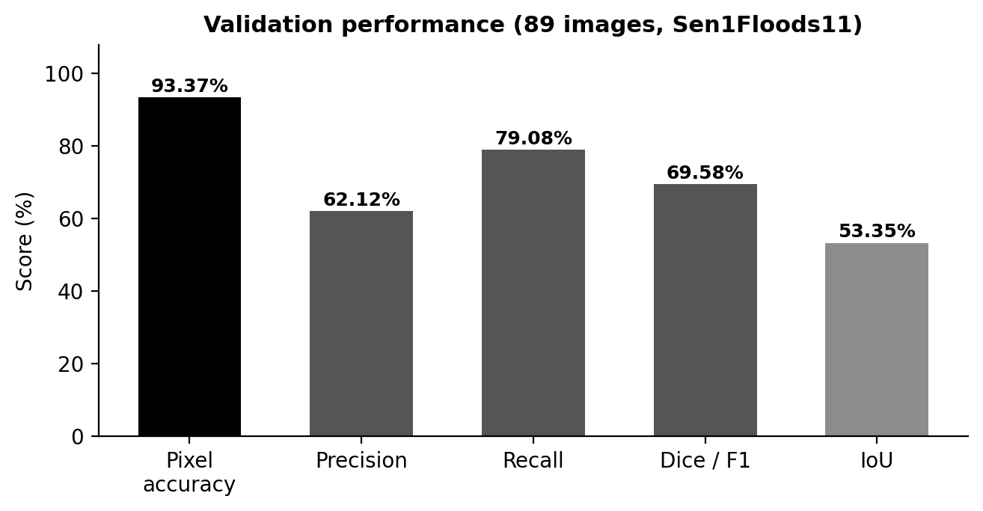
Figure 3. Validation metrics of the trained U-Net + ResNet34 model.

7.3 Discussion
- Recall is higher than precision. The model would rather flag too much than miss real flooding. For a disaster tool this is the safer mistake, although it does cause some false alarms.
- Accuracy alone can mislead. Most pixels are not flooded, so a high accuracy like 93.37% is fairly easy to get. Dice and IoU give a more honest picture.
- The numbers agree with each other. An F1 of 69.58% gives an IoU of F1 / (2 − F1) = 53.35%, which matches our reported IoU.

8. Deep Learning Model V: Inference, Analysis and Limitations

8.1 Inference pipeline
For inference, the Flask route /api/analyze calls infer.py. The uploaded GeoTIFF is read with Rasterio, the two bands are normalised in exactly the same way as in training, and the trained checkpoint predicts a flood-probability map. We convert it to a binary mask and use the raster’s coordinate system and pixel size to calculate the flooded area in km² and the flood percentage. OpenCV then makes a PNG overlay of the mask, which Leaflet draws on the map at the correct location.
Step | Output
Read GeoTIFF (Rasterio) | 2 × H × W array with georeferencing
Normalise | Values scaled to [0, 1]
U-Net forward pass | Per-pixel flood probability
Threshold | Binary flood mask
Area calculation | Flooded area (km²) and flood percentage
Overlay (OpenCV) | PNG mask displayed on Leaflet map

8.2 Strengths of the model
- Skip connections keep the fine details, so the flood boundaries are sharper than with a plain encoder.
- The pretrained ResNet34 encoder makes training faster and helps when the dataset is small.
- Using BCE and Dice loss together copes with the class imbalance that is common in flood images.
- The model is light enough to run on a CPU for a single scene, and it uses a GPU automatically when one is available.

8.3 Limitations
- Average precision (62.12%). Some non-flooded pixels, such as other dark surfaces and shadows in the radar image, get marked as flood.
- No permanent-water baseline. Rivers and lakes that are always there can be counted as flooding. We plan to subtract a permanent-water layer to fix this.
- Small training set. We used only 252 training images, so the performance on new regions such as Tamil Nadu still has to be checked with local data.
- IoU of the deployed checkpoint not logged yet. We still need to record the validation IoU for the deployed checkpoint and test on more images.

8.4 Planned improvements to the model
- Retrain and validate with region-specific ground-truth flood imagery.
- Add permanent-water subtraction and, later, rainfall, river-level and elevation inputs.
- Use GPU compute for larger-scale training and broader hyper-parameter exploration.

9. Population-Aware Risk Analysis and Web Application

9.1 Population exposure and risk score
A flood mask by itself does not tell us who is in danger. So FloodWatch uses WorldPop population data to estimate how many people live in the predicted flooded area. This is written in risk.py, which combines three things into a risk score:
- Flooded percentage of the scene
- Estimated exposed population
- Population density
The score is converted into a High, Medium or Low risk class, so responders can understand the situation at a glance.

9.2 Priority zones, safe zones and hospitals
We split the scene into 32 × 32-pixel tiles. The flooded tiles are ranked by people exposed first, then risk score, flooded pixels and model confidence. Because of this, the system puts the most populated flooded zones first instead of just the biggest ones. For each priority area it also suggests nearby dry evacuation zones and hospitals.

9.3 Web application
Component | Role
Flask backend (app.py) | Serves the dashboard and exposes the API
GET / | Dashboard page
GET /api/health | Health check
POST /api/analyze | Accepts the GeoTIFF and returns mask, area, risk and priority zones
Leaflet.js + OpenStreetMap | Interactive map with the flood-mask overlay
index.html, app.js, style.css | Drag-and-drop upload and results panel

9.4 Prototype status
The prototype works from start to finish. It has a trained model, an inference pipeline (SAR GeoTIFF → flood mask → flooded area → flood percentage), risk scoring based on population, ranking of high-priority zones, logic for recommending safe zones and hospitals, and a complete Flask and Leaflet dashboard with drag-and-drop upload.

10. Feasibility, Scalability and Impact

10.1 Feasibility today
- The core model, inference pipeline and dashboard work end to end.
- The system is built entirely on free, globally available data and open-source software: Sentinel-1/2 imagery, Sen1Floods11, WorldPop and OpenStreetMap.

10.2 Scalability and next steps
- Integrate real-time Sentinel-1 data ingestion and automated alerting.
- Extend population data beyond India to global coverage.
- Add rainfall, river-level and elevation data to close the satellite revisit-time gap.
- Retrain and validate with region-specific ground-truth flood imagery.
- Add permanent-water baseline subtraction to separate new flooding from existing rivers and lakes.
- Pilot with a local disaster management authority using a real regional flood event.

10.3 Measurable impact
- Reduces flood-extent mapping from days (manual or ground survey) to minutes.
- Directs rescue resources to the most populated flooded zones first, not just the largest.
- Success is measured by response-time reduction to high-priority zones and by model IoU and precision on validation data.
- Designed to scale from a single district to state-level and national-level flood monitoring.

10.4 Support needed
To take the project from a prototype to a real pilot, we would need more population and infrastructure datasets, GPU compute for bigger training runs, and guidance from experts in disaster management.

11. Conclusion

11.1 Conclusion
FloodWatch shows that a fairly small deep-learning model can turn raw Sentinel-1 SAR images into useful flood information. Our PyTorch U-Net with a ResNet34 encoder, trained on Sen1Floods11 with BCE and Dice loss, reached 93.37% pixel accuracy, 79.08% recall, 69.58% Dice/F1 and 53.35% IoU on the validation set. By adding WorldPop population data, tile-wise ranking and safe-zone and hospital suggestions, FloodWatch goes beyond just mapping floods and helps answer the question responders really face: where to act first.
Our main limitations are the average precision, the missing permanent-water baseline and the limited testing on regional data, and all of them can be improved. With region-specific retraining, permanent-water subtraction, real-time data and a pilot with a disaster management authority, we hope FloodWatch can become a practical tool for flood-prone regions like Tamil Nadu.

12. Individual Contributions:
Akhilon S : Deep Learning & Computer Vision
- Handled the ingestion and preprocessing of Sentinel-1 SAR satellite imagery using Rasterio and NumPy.
- Built the core deep learning architecture in PyTorch, utilizing a U-Net with a ResNet34 encoder for semantic segmentation.
- Managed the model training pipeline on the Sen1Floods11 dataset, applying Albumentations for data augmentation.
- Optimized the model using a combination of Binary Cross-Entropy (BCE) and Dice Loss to handle class imbalance between dry and flooded pixels.
Gowtham S : Geospatial Mapping, Population & Risk Analytics
- Developed the web application backend using Flask to process incoming satellite image files.
- Engineered the interactive geospatial map overlay using OpenCV, Leaflet.js, and OpenStreetMap.
- Calculated human risk metrics by integrating WorldPop demographic data with the flood mask to estimate exposed populations.
- Designed the rescue prioritization and routing logic by dividing the map into micro-zones and querying the OpenStreetMap Overpass API to locate nearby hospitals and safe zones.

